# Task Solution:- Oodles Technologies Pvt LtdOodles

# Git repository:

https://github.com/OCTO01032020-araju/Jva-mysql-docker-compose.git

* java-mysql-compose:- java springboot source code
  + application source code
  + dbdate created while compose
  + Dockerfile for Java Springboot
  + Docker-compose.yml
* AWS Tasks
* Doc file of aws task and screenshots of docker-compose running

**Command used:**

$Docker-compose up --build

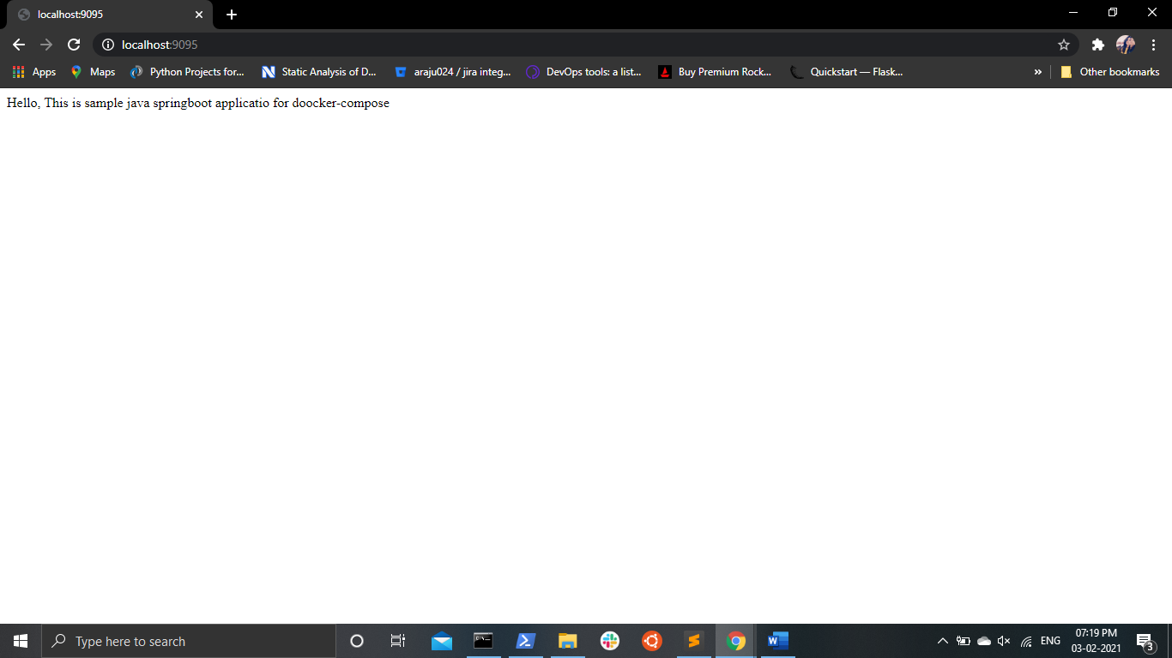

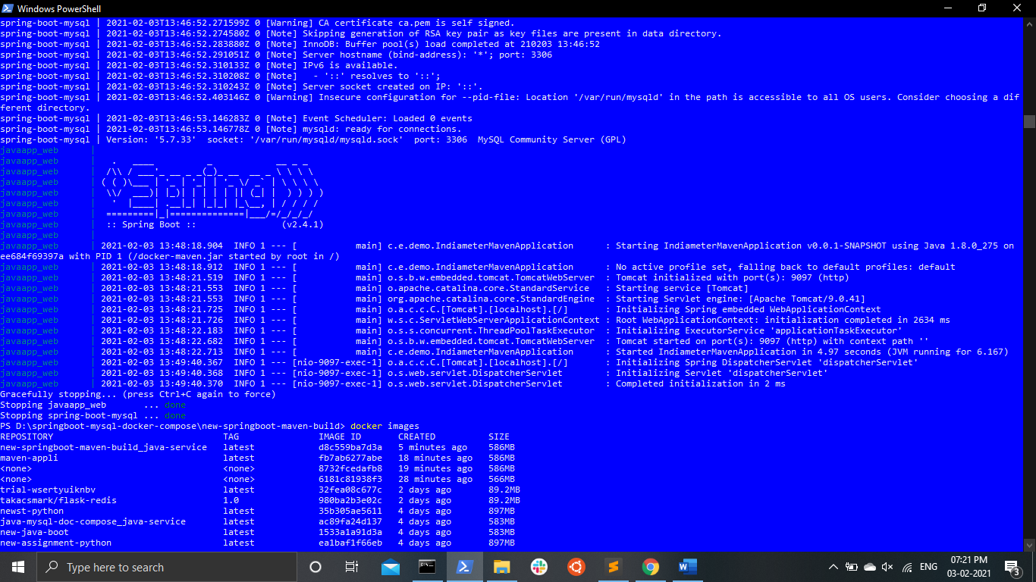

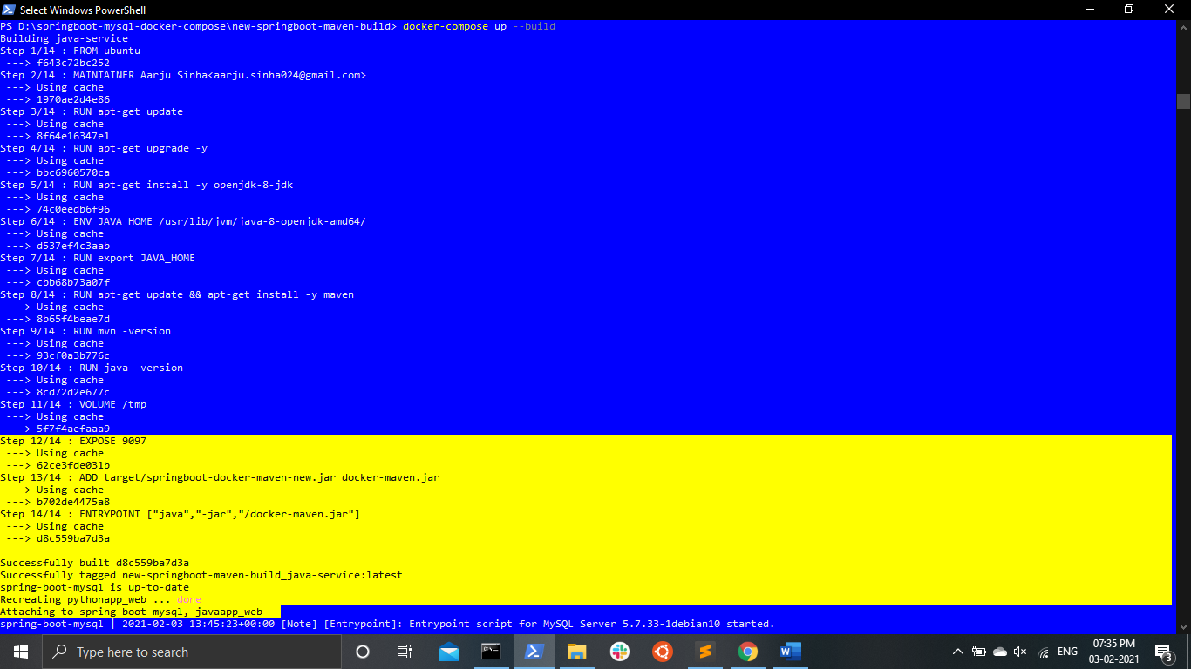

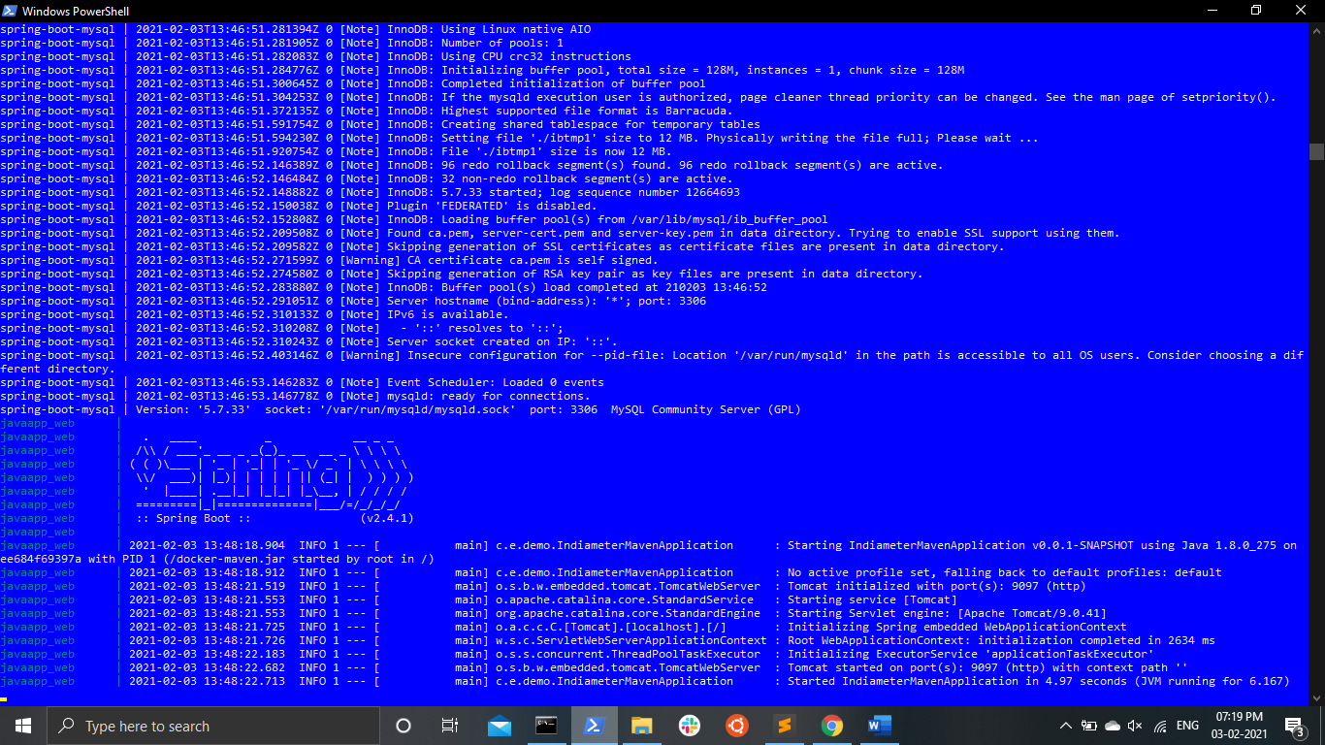

**AWS Task**

# Created a dev VPC

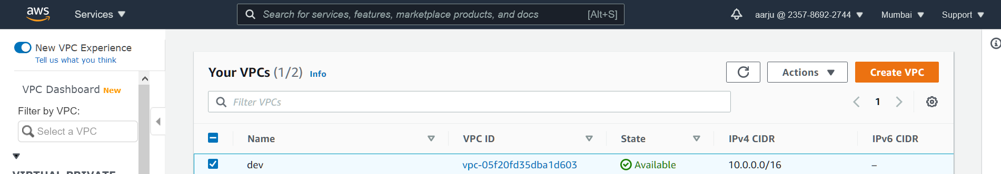

Created a subnet with /24 cidr

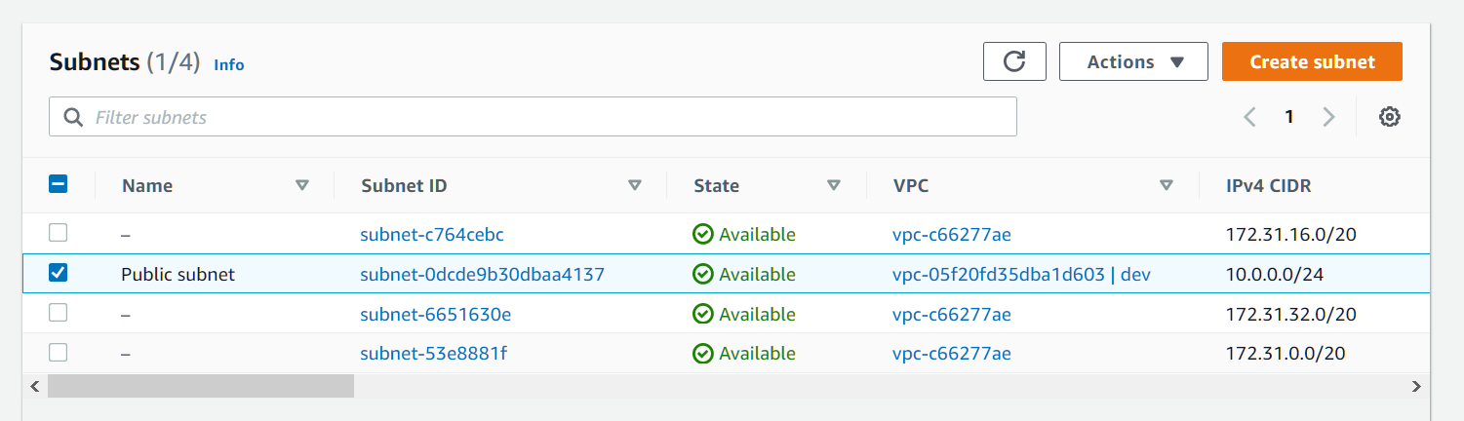

Change route tables

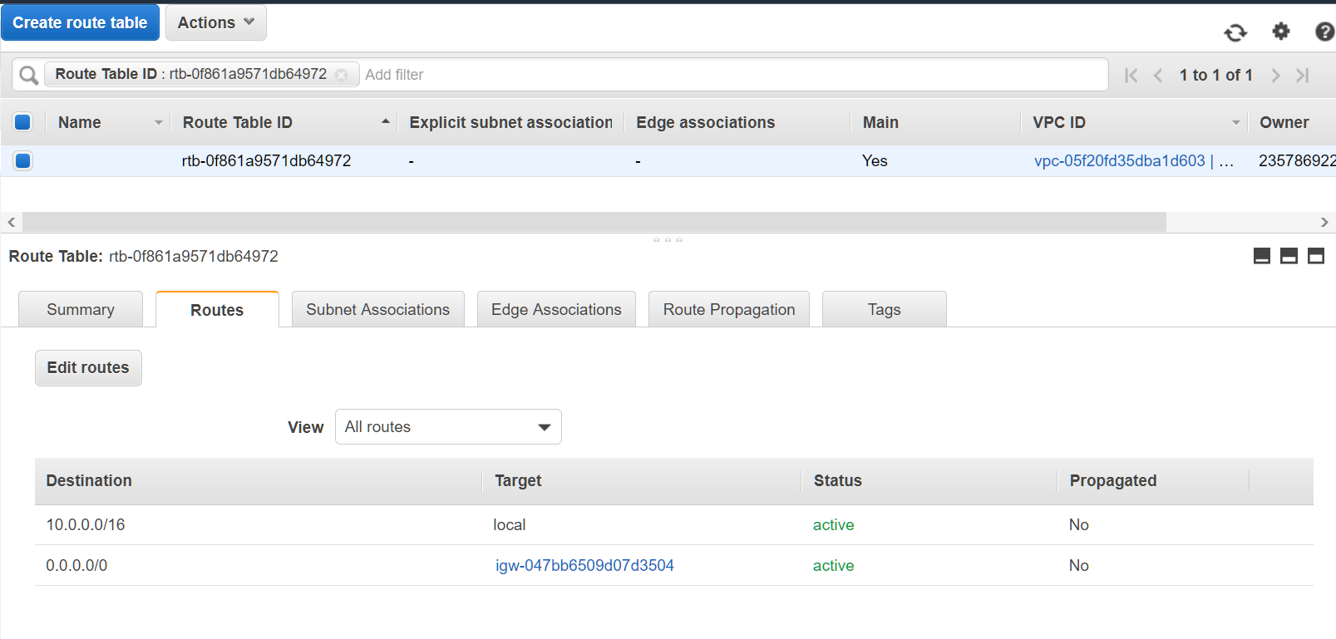

Launched a new server

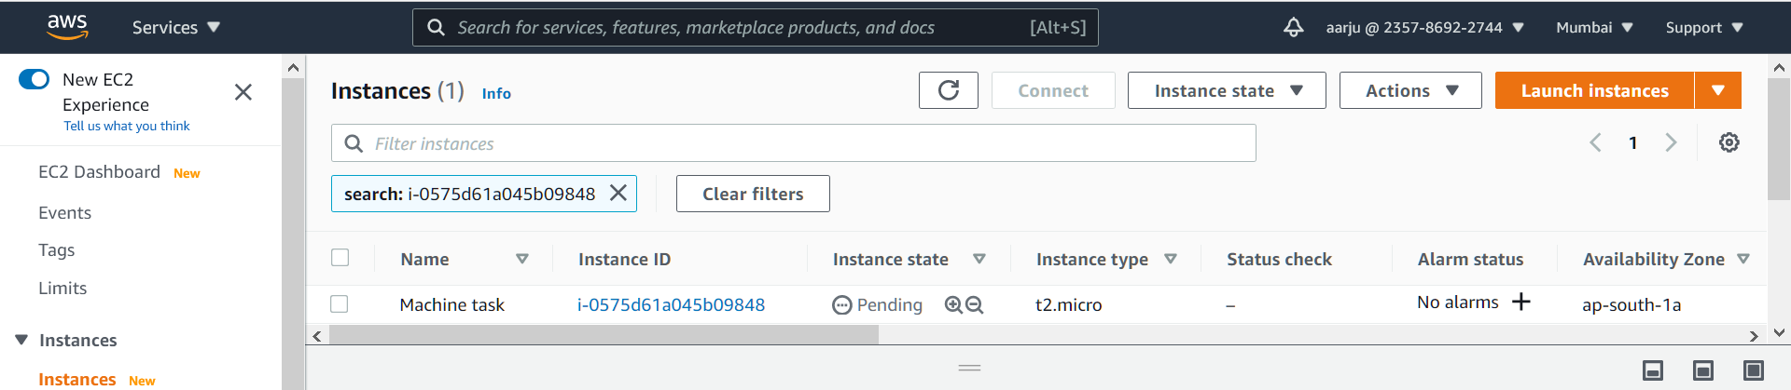

Security group

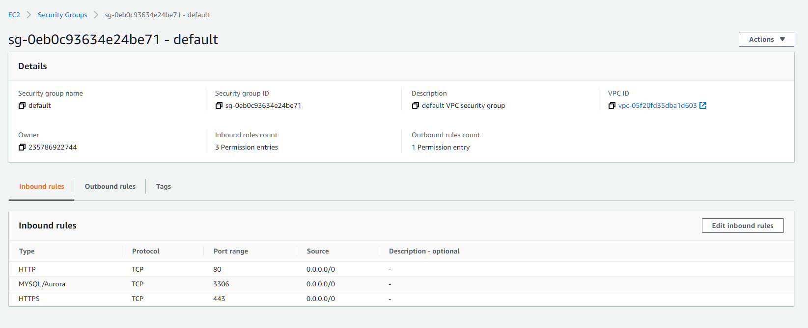

Changed server name



Added user

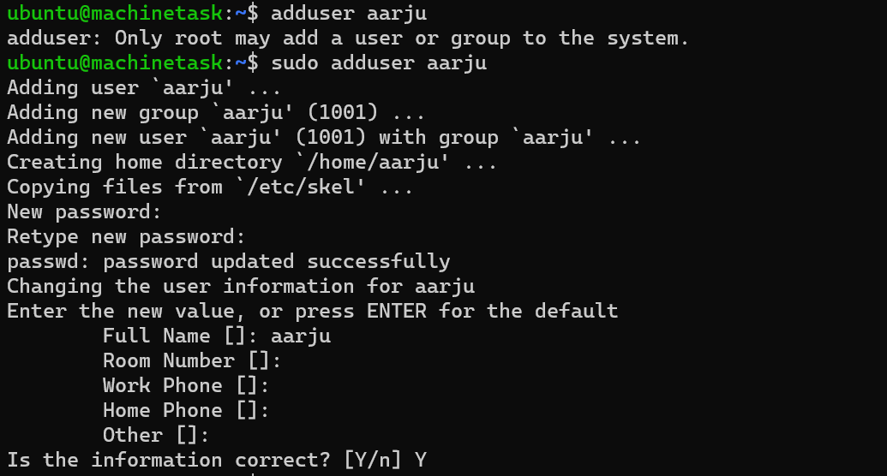



**SSH KEY - Not to be shared**

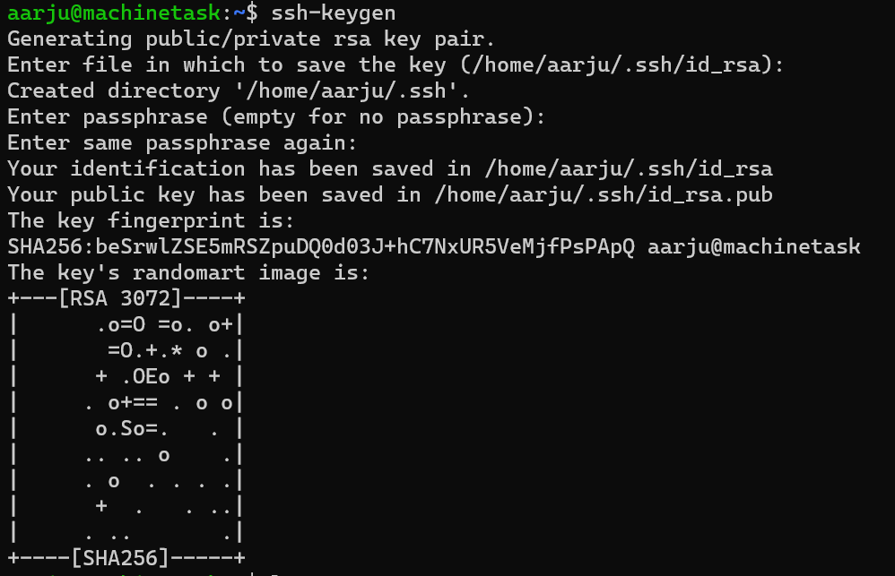



**A running ec2 with jdk and java application deployed using Dockerfile**

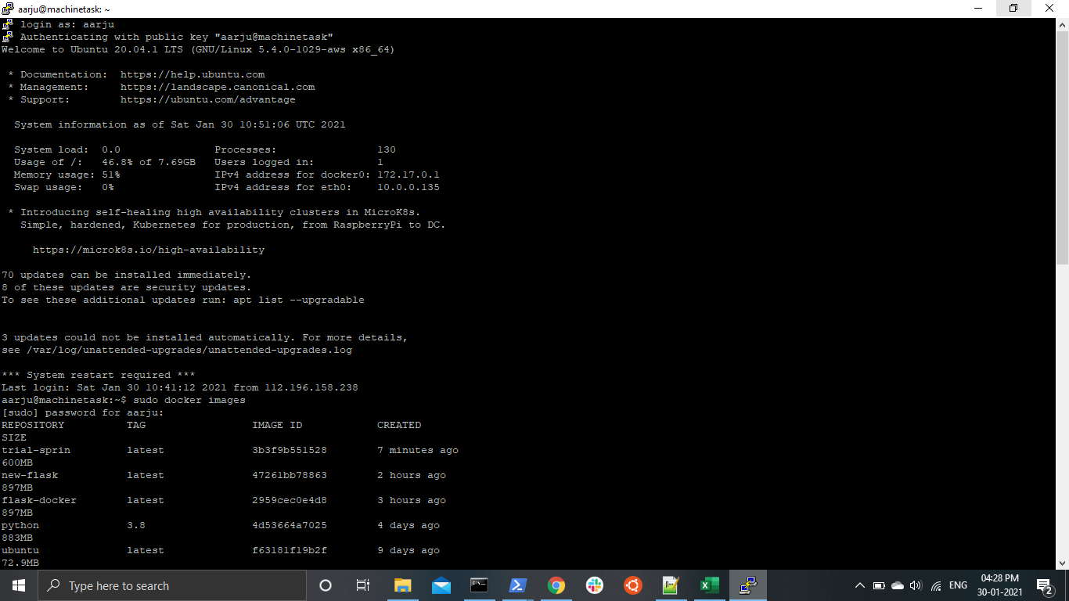

The elastic IP on the EC2 instance attached with EC2 machinetask instance

